|  |
| --- |
|  |
|  |
| Instructions for the author: Headings present in the document should not be deleted |
|  |
|  |
|  |
|  |
| Naming Convention Tool User Guide |
|  |
|  |

|  |  |  |  |
| --- | --- | --- | --- |
| Author | Affiliation | Editor | Approver |
| Jakob Battelino Prelog | Cosylab d. d. |  |  |

Document revision history

|  |  |  |
| --- | --- | --- |
| Version | Reason for revision | Date |
| 1.0 | New Document | 2014-01-07 |

Table of Contents

1. Context 3

2. References – Relevant documentation 3

3. Title 1 3

3.1 Title 2 3

3.1.1 Title 3 3

3.1.1.1 Title 4 3

4. Deliverables 3

5. Deadlines 3

6. Offer content - Amount 3

# Overview

Naming convention tool is a web application, which enables constructing and adding device names that adhere to the naming convention. At the most basic division of functionality, it implements two distinct workflows: one for managing name parts and one for managing the device names themselves. Each workflow is covered in more details further along in this document.

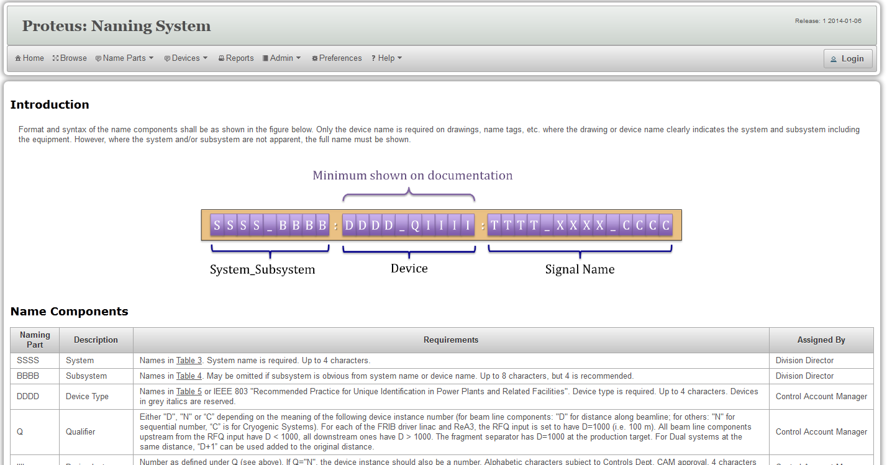

Naming convention tool enables name manipulation in many different ways. To avoid unwanted changes as much as possible, some of the functionalities are restricted to certain types of users. The tool recognizes three different types of users:

* Guest
* Device Editor
* Super user

In order to be recognized as a user with certain privileges, a user first has to log in. If the user is not logged in, he is deemed to be a guest user.

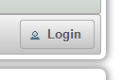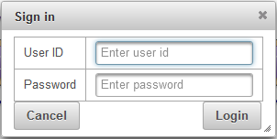User can log in by clicking on the **Login** button in the top-right corner on the application and then entering the user ID and password into the login window (pictured below).

Users that are not logged in (guest users) may still use certain features of the application. They may browse the name parts, they may list the current device names and they may generate reports for themselves. Browsing the name parts can be done by clicking **Browse** in the top menu. Examining the list of currently existing device names may be done by selecting **List Devices** in the **Devices** submenu. Reports can be generated on the reports screen, accessed by clicking **Reports** in the top menu.

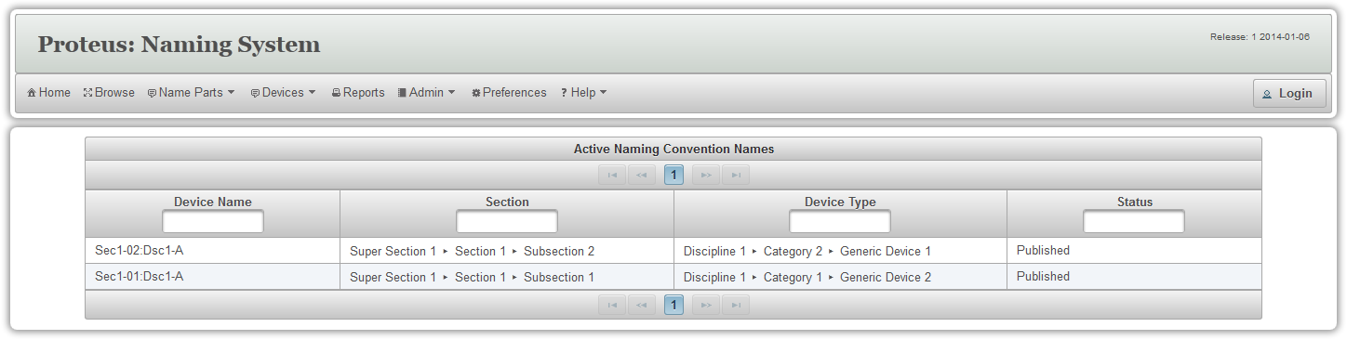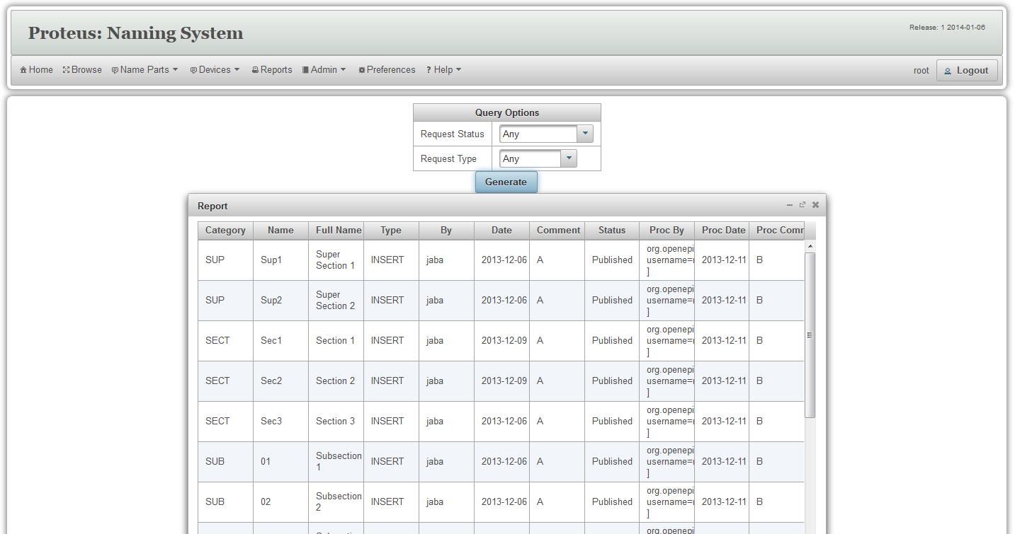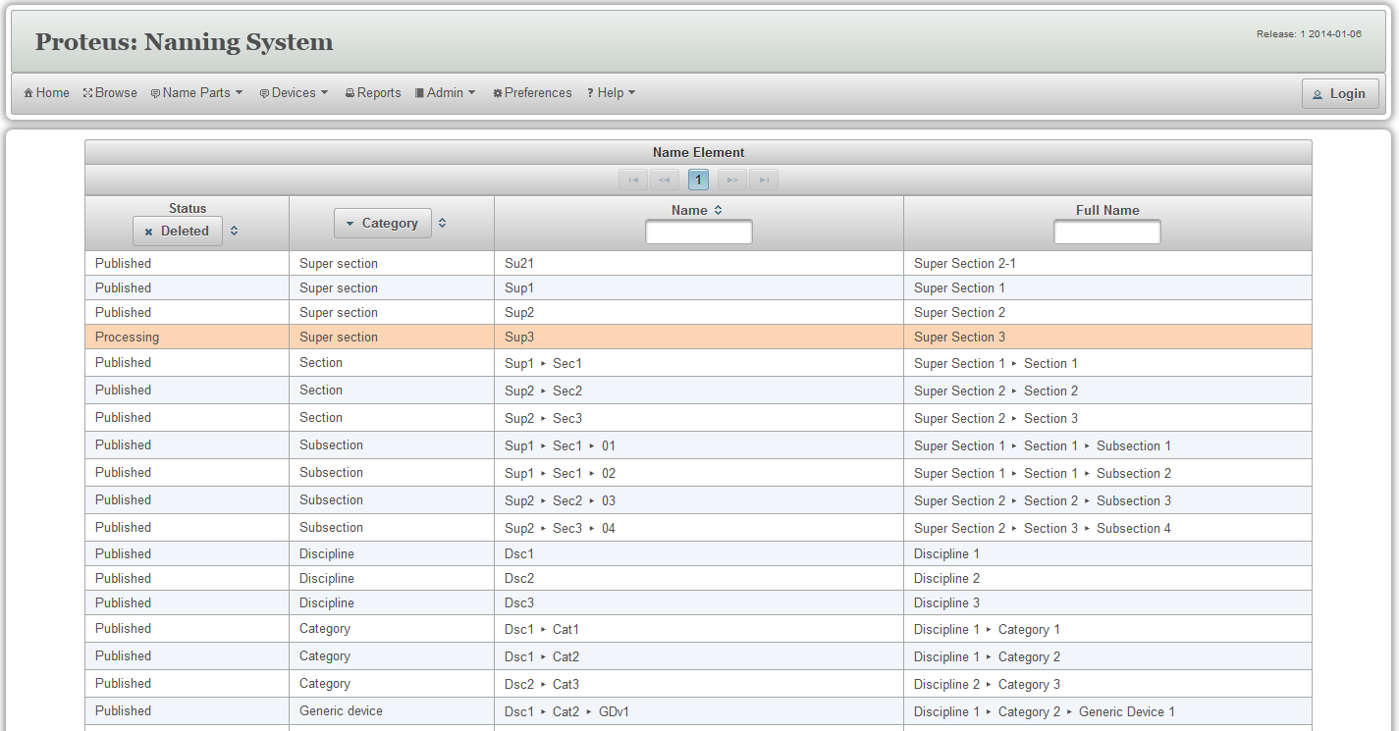

# Working With Name Parts

Each device name that adheres to the naming convention is constructed from name building blocks – name parts. These are short tags of facilities, the device is located in and short tags for device type classification categories.

Only device editors and super users may manipulate name parts, so in order to use any of the name part manipulation screens the user has to be logged in.

Once logged in, a user can submit requests for adding new, changing or deleting name parts, and review the status of his previous requests.

All changes to the name parts are done through **Submit Change Request** screen, which can be accessed by selecting **Submit Request** in the **Name parts** submenu. This opens up a screen pictured below.

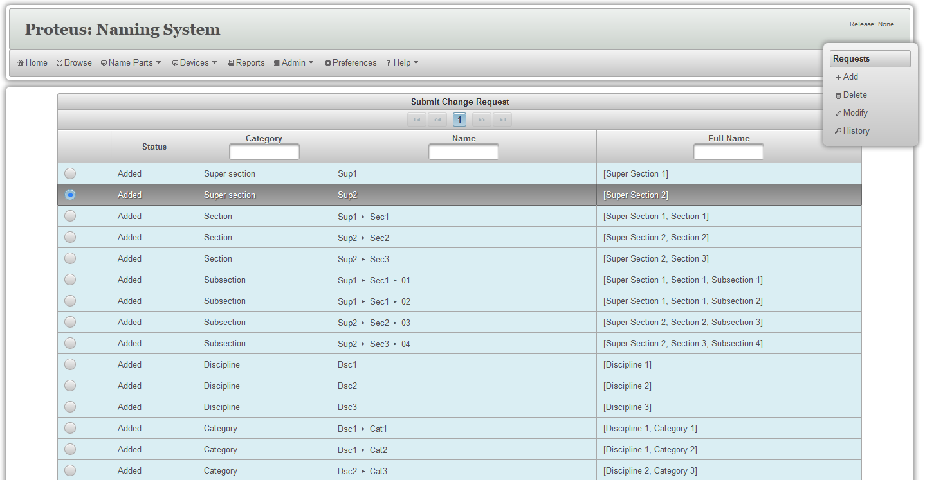

On this screen there is a table of all current name parts, their category, place in hierarchy and status. On the right hand side, there is also a small floating menu, presenting all name part manipulation possibilities. Some of these options may be unavailable, based on the current table selection.

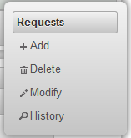

To add a new name part, a user must click the **Add** button in the side menu. This will pop up a form in a window, pictured below.

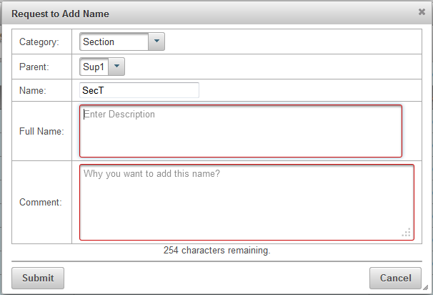Here the user must select a name category for the name part, its short name tag, full name and add a comment to the request. Selecting a parent name part may be optional, depending on the hierarchy of name categories in the naming convention. After filling in the form and clicking **Submit** button a new entry will be added to the table. The will have a status **In-Process**.

To modify an existing entry select an entry in the table and click on the **Modify** button in the side menu. This will pop up a windowed form, very similar to the one for adding a new name part. The user must fill in the form, exactly like when adding a new name part. After clicking the **Submit** button, the selected entry will have its status changed to **In-Process**.

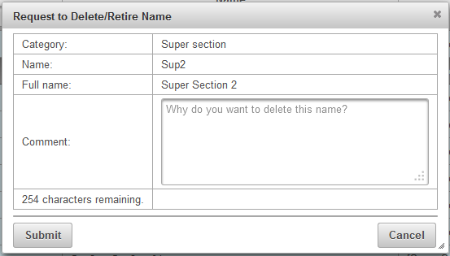Deleting an entry is done the same way. Selecting an entry from the table and clicking the Delete button will open up a windowed form, where a user may request a name part to be deleted and provide a comment on this. Once the entry is requested to be deleted, it is also marked **In-Progress**.

All name part entries related to the current user can be reviewed in a separate screen that can be accessed by selecting **My Requests** in the **Name Parts** submenu. It looks very similar to the **Submit Change Request** screen and looks like in the picture below.

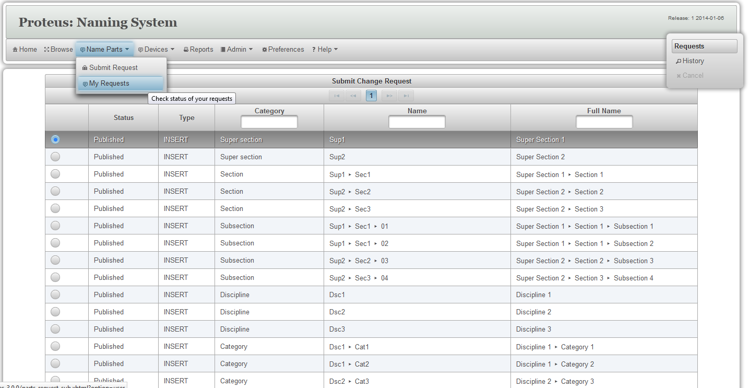

In both views, change history of a specific name part may be viewed by selecting the name part entry in the table and then click on the **History** button on the side menu. History is represented in a table of chronologically ordered entries, looking like this:

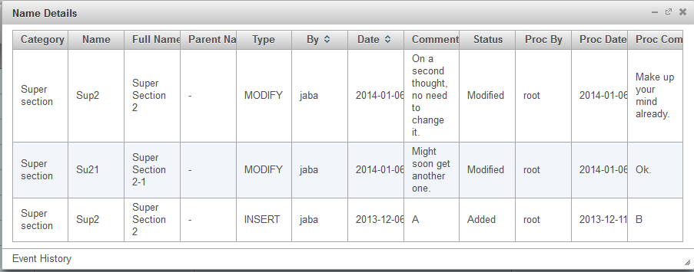

Logging in as a super user gives a user additional capabilities. Super users can approve new name parts, changes to the existing ones and also publish names.

Approving or rejecting new name parts, or to approving or rejecting changes to the old ones is done through the **Process Requests** screen. This screen may only be accessed by super users by selecting **Process Requests** in the **Admin** submenu and it looks like in the picture below.

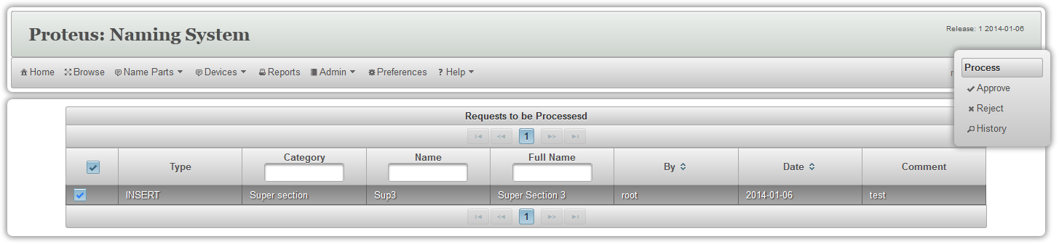Here only requests with status **In-Process** are displayed. User can then select such an entry and click either **Approve** or **Reject** button. Request’s status will then be set to the appropriate status value.

# Working With Device Names

Only Device Editors and Super users may manipulate device names, so in order to do anything else but look at the list of current device names the user has to be logged in.

Once logged in a user can construct new device names, change existing ones or request for them to be deleted.

All manipulation of the device names is done through the **Manage Devices** screen, accessed by selecting **Manage Devices** in the **Devices** submenu. This opens up a screen similar to the picture below.

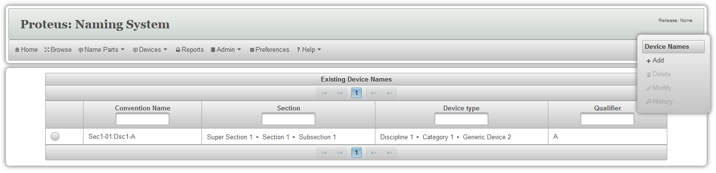In the table on this screen are all the device names currently in the device name database. The table can be filtered by part of the convention name, section name, device type, or by the device name instance index (qualifier).

To add a new device name a user must click the **Add** button on the floating menu on the right-hand side (in the picture).

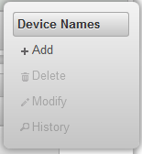This will open up the **Add Device Name** form in a pop-up window, where user can construct a new device name from the existing name parts. Precise information required in constructing a name is dependant of the naming convention, but drop-down lists are provided and automatically populated to ensure hierarchical consistency of the constructed name. Once the required name parts have been selected the **Submit** button will become enabled. After clicking it, if there is no problem with the name, a notification will pop up (pictured below) and the new name entry will appear in the table.

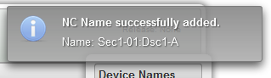To modify an existing device name, user first has to select it in the table and then click on the **Modify** button in the side menu. This will open up a windowed form very similar to the one used for adding new names. After modifying the name, user must click the **Submit** button on the form, to commit the changes.

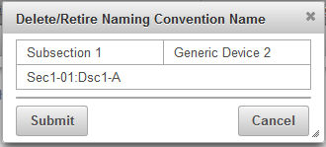Deleting a name is done in a similar fashion. User must first select a name entry in the table and then click on the **Delete** button in the side menu. This opens up a confirmation window similar to the one in the picture below. Deletion is confirmed once the user presses the **Submit** button on the form.

# FAQ

## Table Entries

### What do the different colors mean?

Table entry background colors indicate entry statuses. Explanations of statuses and corresponding colors are in the table below.

| Color | Meaning |
| --- | --- |
| PROCESSING | Name is being processed. |
| APPROVED | Name has been approved, but has not yet been published. |
| APPROVED | Name has been approved and has already been published. |
| CANCELED | Request for adding this name has been canceled by the proposer. |
| REJECTED | Request for adding this name has been rejected by the approver. |

### What do the different font styles mean?

Table entry font styles represent different types of events. Explanations of event types and corresponding font styles are in the table below.

| Style | Meaning |
| --- | --- |
| TEXT | Name has been inserted, but has not yet been processed. |
| TEXT | Name has been and still is approved. |
| TEXT ~~(TEXT)~~ | Name has been modified. Brown text shows the new value and the golden, stricken-through text the old one. |
| TEXT ~~(TEXT)~~ | The name has been canceled by the proposer. Strike-through text shows the old value. Accompanied by light blue background it also indicates deletion of an approved name. |
| ***TEXT ~~(TEXT)~~*** | The name has been rejected by the approver. Strike-through text shows the old value. |
| ~~TEXT~~ | Entries completely struck-through indicate deleted names. |

## Device Names

### How to browse the list of approved device names?

Anybody may browse the list of approved device names.

To see the list of all approved device names, select List Device Names from the Device Names menu."

### How to browse the list of all device names?

Only naming administrators and device editors may see the list of all device names.

To see the list of all device names, first log in.

Then select Manage Device Names from the Device Names menu."

### How to request a new device name?

Only naming administrators and device editors may request new device names.

To request a new device name, first log in.

Then select Manage Device Names from the Device Names menu.

On the right-hand-side press the Add button to open up a form in a pop-up window.

Fill in the form with information about the device and press Submit.

### How to modify a device name?

Only naming administrators and device editors may modify device names.

To modify a device name, first log in.

Then select Manage Device Names from the Device Names menu.

Select a device name form the table and press the Modify button on the right-hand-side to open up a form in a pop-up window.

Fill in the form with modified information about the device and press Submit.

### How to approve a new device name?

Only naming administrators may approve device names.

To approve a device name, first log in as a naming administrator.

Then select Manage Device Names from the Device Names menu.

Select a device name form the table and press the Approve button on the right-hand-side to approve the device name.

## Name Parts

### To browse the list of current names

Select Browse from the main menu.

### What is the latest released naming standard?

The name and date of the latest release standard are shown on the top right corner. The latest naming standard document is available under Help menu.

### To submit a change request

If you are not logged in, you must first login.

If you are logged in, select Submit Request under Request menu.

On the request page, choose from the Requests pop-up menu to Add, Modify, or Delete a name.

### To check the status of your request

If you are not logged in, you must first login.

If you are logged in, select My Requests under Request menu.

### To check the status of your request

If you are not logged in, you must first login.

If you are logged in, select My Requests under Request menu.

Select the request, and choose 'Cancel' from the Requests pop-up menu"

### To process requests

You must be logged in, and authorized to process requests.

Select Process Requests under the Admin menu.

Select one or more requests, and choose approve or Reject from the Process pop-up menu.

### To publish a new naming standard

You must be logged in, and authorized to publish naming standards.

Select Publish Names under the Admin menu.

Select Publish from the Publish pop-up menu.